Ryan Napolitano (rn2473)

Computer Vision, Spring 2021

Professor Nayar

Homework 4 – written assignment

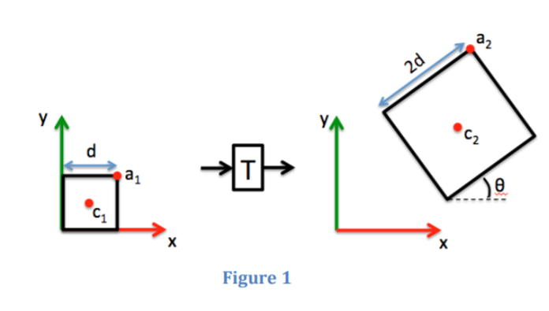

The transformation matrix T from the figure 1 can be written as a chain of 3 matrices each of which has a single function:

**T** = **S M R**

Where, S is scaling matrix, M is translation matrix and R is rotation matrix.

S = $\left[\begin{matrix}s_{x} & 0 & 0 \\ 0 & s_{y} & 0 \\ 0 & 0 & 1\end{matrix}\right]$ = $\left[\begin{matrix}2 & 0 & 0 \\ 0 & 2 & 0 \\ 0 & 0 & 1\end{matrix}\right]$

M = $\left[\begin{matrix}0 & 0 & t_{x} \\ 0 & 0 & t_{y} \\ 0 & 0 & 1\end{matrix}\right]$ = $\left[\begin{matrix}0 & 0 & x_{2}-x_{1} \\ 0 & 0 & y_{2}-y_{1} \\ 0 & 0 & 1\end{matrix}\right]$

R = $\left[\begin{matrix}cos⁡(θ) & -sin⁡(θ) & 0 \\ sin⁡(θ) & cos⁡(θ) & 0 \\ 0 & 0 & 1\end{matrix}\right]$